**Avaamo Assignemt**:

**Code: Write a short program that prints each number from 1 to 100 on a new line. For each multiple of 3, print "AVA" instead of the number. For each multiple of 5, print "AMO" instead of the number. For numbers which are multiples of both 3 and 5, print "AVAAMO" instead of the number. NB: Any programming/scripting language can be used to do the above**

**Network:**

**Show how to list open files and kill processes tied to a user**

**Network:**

**Show the list of IPs a process is connected to**

**Network:**

**Show list of processes using the network**

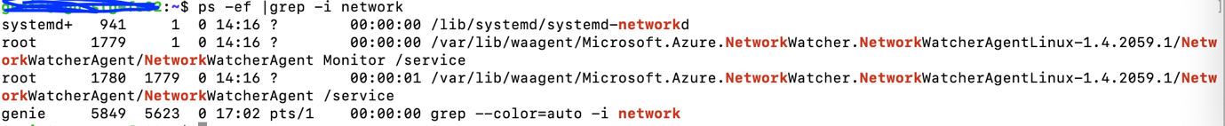

**Monitoring using scripts:**

**Monitor process particular process on an instance, send an email on incase of state change like process got stopped, taking more CPU that threshold**

**Git commands:**

**How do you find a list of files that have changed in a particular commit?**

**Monitoring using scripts**:

**Monitor a log file, detect a pattern detection, send an email on detection**

Security:

1. Show how to block ports

sudo ufw allow 8080

 sudo ufw allow OpenSSH

Sudo ufw deny 8080

2. Show how to setup port forwarding

Port forwarding

ssh -L 9090:webserver:80 ubnt@sshserver

L Localhost

9090: any free port

webserver: our web server which we need access on localhost

Sshserver: with which localhost will establish a tunnel

[127.0.0.1:9090](http://127.0.0.1:9090/)